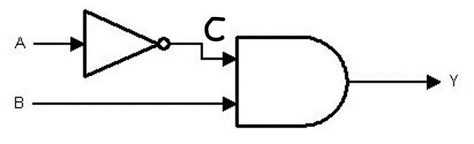

|  |  |  |  |
| --- | --- | --- | --- |
| **A** | **B** | **C** | **Y** |
| 0 | 0 | 0 | 0 |
| 1 | 1 | 0 | 0 |
| 0 | 1 | 0 | 0 |
| 1 | 0 | 1 | 1 |

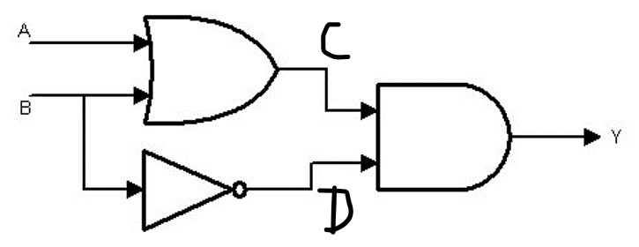

|  |  |  |  |  |
| --- | --- | --- | --- | --- |
| **A** | **B** | **C** | **D** | **Y** |
| 1 | 0 | 0 | 0 | 0 |
| 0 | 1 | 1 | 0 | 0 |
| 0 | 0 | 1 | 0 | 1 |
| 1 | 1 | 0 | 1 | 1 |

**3**

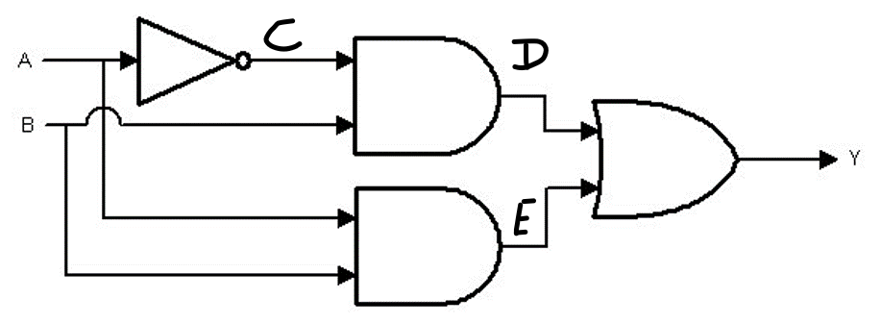

|  |  |  |  |  |  |
| --- | --- | --- | --- | --- | --- |
| A | B | C | D | E | Y |
| 0 | 0 | 0 | 0 | 1 | 1 |
| 0 | 1 | 0 | 1 | 0 | 1 |
| 1 | 0 | 1 | 1 | 1 | 0 |
| 1 | 1 | 1 | 1 | 1 | 0 |